Advent – The Coming
The season of Advent is the four week time of preparation for the coming of Jesus. Advent also anticipates Jesus return again one day. It begins on the Sunday nearest to November 30. This year Advent begins on Sunday, November 29 and continues until Christmas Eve on December 24.
We observe this holy season by lighting candles each of the four Sundays in Advent.
As you light these candles in your home each week, know that you are acting in concert with millions of Christ followers all around the world. May Advent be a season of centering and renewal, as well as a source of peace for you and yours. God bless you!

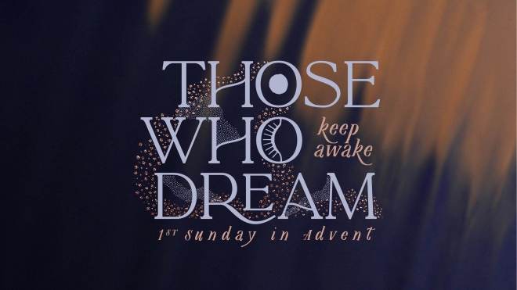The Candle of Hope
A: I dream of sunflower fields.
B: I dream of key lime pie with a mile-high meringue.
A: I dream of the days when we could be part of a crowd.
B: I dream of snow days.
A: I dream of empty beds in jail cells.
B: I dream of a world that will let kids be kids.
A: I dream of full tables instead of empty bellies.
B: I dream of schools with enough money to teach.
A: I dream of parents with enough money to feed.
B: I dream to keep awake, because if we don’t dream of better days, then we might forget that this
is not what God imagined.
A: So today we light the candle of hope, for hope is the very thing that keeps dreams afloat.
Light candle.
B: May this light be an invitation to keep awake.
A: May this light be our invitation to be Advent people—people who dream.
Amen.

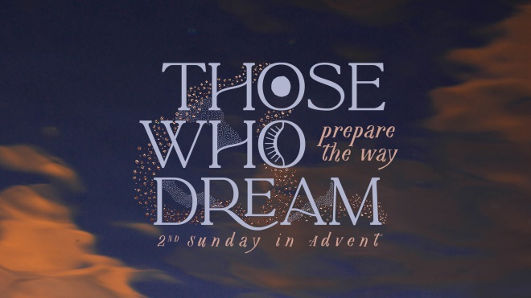The Candle of Peace
A: I dream of the first pitch of opening season.
B: I dream of a laundry day, where each sock finds its mate.
A: I dream of family home for the holidays.
B: I dream of good books and homemade meals.
A: I dream of sunset drives with the windows down.
B: These are beautiful dreams, but I also have urgent dreams.
A: I dream of conversations across party lines. B: I dream of more bridges and less walls.
A: I dream of more laughter and less fear.
B: I dream of more listening and less tears.
A: But most of all, I dream of peace like a river.
B: Today we light the candle of peace.
Light candle.
B: May it remind us that there is another way. Amen.

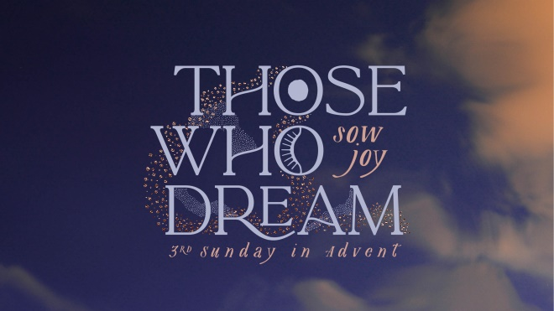The Candle of Joy
A: I dream of dance parties in the kitchen.
B: I dream of laughter that is contagious.
A: I dream of birthday candles and another beautiful year.
B: I dream of family game nights and dinner parties with friends.
A: I dream of homemade Halloween costumes and homemade family recipes.
B: I dream of pillow forts, fireflies, and front porch swings.
A: I dream of every little thing that brings joy; and I know it comes from God.
B: So today we light the candle of joy as a reminder that God’s dream for this world involves the end of all tears.
Light candle.
A: God’s dream for this world involves a joy that overflows and is contagious.
B: So may this fire burn bright, and as it does, may we sing.
A: May we dance.
B: May we laugh.
A: May we hold onto the people we love.
B: May we sow joy in a hurting world, and may it be an act of holy resistance. Amen.

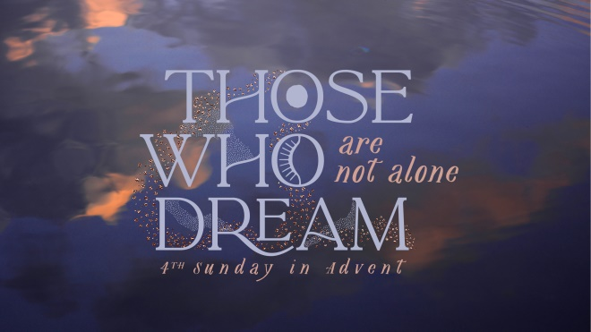
The Candle of Love
A: I dream of music that makes my heart swell.
B: I dream of trees that take my breath away.
A: I dream of sunrises that wrap me in light.
B: I dream of family dinners that feel like home.
A: I dream of church services that give me hope.
B: I dream of love as the default.
A: So today, as we draw near to Christmas day, we light the candle of love. Light candle.
B: May this light burn bright as a reminder that God is here and God is love.
A: We are not alone. Thanks be to God for a love like that. Amen.
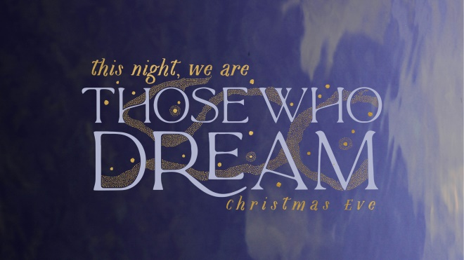The Christ Candle
A: In the beginning, God dreamed of a beautiful world.
B: In Egypt, the Israelites dreamed of freedom.
A: In the wilderness, the people dreamed of safety.
B: In Jerusalem, the people dreamed of a Messiah.
A: In Bethlehem, the shepherds and Wise Men dreamed of a new beginning.
B: Then, several years later, Jesus walked this earth and dreams came true.
A: The sick were healed.
A: The poor had food.
B: The forgotten and ignored were seen.
A: The children were welcomed.
B: Everyone was invited to the table, and the world has never been the same.
A: So tonight, we are those who dream.
B: Tonight, we dream the same dreams of our ancestors before us.
A: Tonight, we dream of justice and mercy, of love and kindness, of peace and hope.
B: Tonight we dream of a God that draws near to us out of unfailing love.
A: May this candle be a reminder that there will be a day when every dream will be fulfilled. And until then, we will be those who dream. B: Let us worship Holy God.
Candle Lighting Readings
2020
Advent and Christmas Eve
Fairport UMC

What does it look like to live as those who dream? The prophets, the psalmists, John the Baptist, Mary, Elizabeth, Joseph, Simeon, Anna, the shepherds and the Magi—they were all dreamers. They received, discovered, and responded to God’s dreams for the world. In Advent, we step into the mystery and awe of God’s dreams and pray they shape our reality.

This theme is for the dreamers in all of us—those who dream of a deeper connection with God and those who dream of a better world. It’s for those who dream of comfort and for those who have given up on their dreams. It’s for those whose dreams have been crushed and for those who show us that dreams take time. Join us this Advent as we dream alongside prophets and angels, Mary and the Magi. Join us as we seek and sow God’s dreams for our world.

Liturgy by Sarah Are | A Sanctified Art LLC | sanctifiedart.org.

