ASH WEDNESDAY
AGAIN & AGAIN, WE’RE INVITED IN
Matthew 6:1-16, 16-21 | Isaiah 58:1-12
As Lent begins, we’re invited in—to community, to this season, to our own spiritual journey, to true transformation. We’re on this journey together, but we’re invited to turn inward. Therefore, spiritual practices are not for show. Matthew 6 and Isaiah 58 remind us that performative acts (of piety and justice) are not the way.

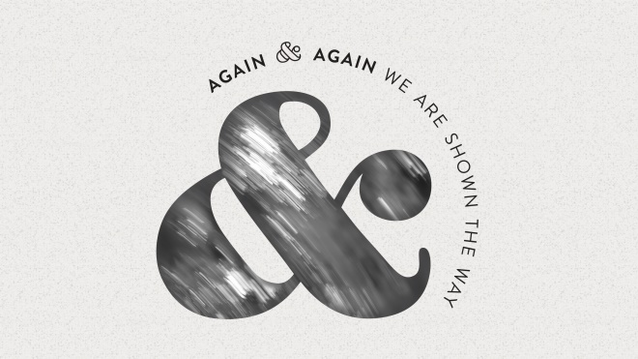
FIRST SUNDAY IN LENT
AGAIN & AGAIN, GOD MEETS US

Mark 1:9-15 | Genesis 9:8-17
God meets Jesus at the water before he is tempted in the wilderness—this is important. First and foremost, God claims us. God meets us in the liminal space, at the water’s edge, at the threshold of something new, and names us Beloved. God’s covenant with all of creation reminds us that God meets us where we are—in the midst of our reluctance, doubt, eagerness, or weariness—and proclaims we are good.
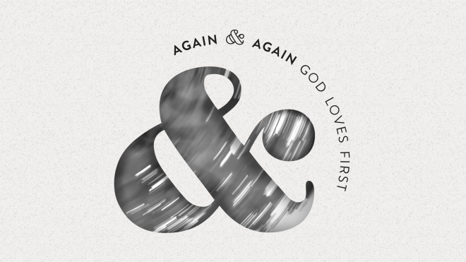
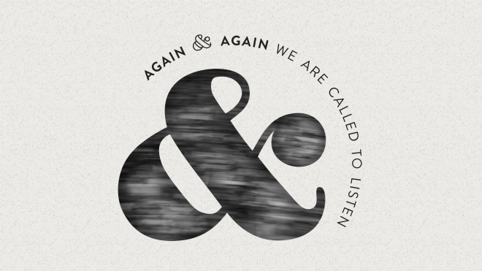
SECOND SUNDAY IN LENT
AGAIN & AGAIN, WE ARE CALLED TO LISTEN
Mark 8:31-9:8¹ | Psalm 22:23-31
Like the disciples, we are often stuck in the pattern of messing up over and over again. We cling to power, we climb the ladder, we memorialize Christ’s teachings rather than embodying them. However, we can’t be trapped by shame, guilt, ignorance, or inaction. Humility is required for transformation. Again and again, we are called to listen—to God and to others.
THE THIRD SUNDAY IN LENT
AGAIN & AGAIN, WE ARE SHOWN THE WAY

John 2:13-22 | 1 Corinthians 1:18-25
According to John, Jesus begins his ministry by showing more than telling. In the temple, Jesus disrupts and overturns the systems of corruption and profiteering taking place, but ultimately points us to the promise of restoration. Paul reminds the Corinthians (and us) that God’s wisdom is more expansive than we can imagine. We are shown the way, even if God’s “way” feels foolish, counter-cultural, disruptive, or uncomfortable.

THE FOURTH SUNDAY IN LENT
AGAIN & AGAIN, GOD LOVES FIRST

John 3:14-21 | Ephesians 2:1-10
After inviting Nicodemus to be born anew, Jesus tells him in John 3 that God so loved the world that God sent his son to restore it. Therefore, when we read John 3:16, we remember that Jesus is speaking in metaphor and poetry. Ultimately, love is where God begins and ends. This love, like grace, is a gift we do nothing to deserve. Again and again, love is our refrain. Before we act, think, or believe, can love be first for us too?
THE FIFTH SUNDAY IN LENT
AGAIN & AGAIN, WE ARE REFORMED

John 12:20-33 | Jeremiah 31:31-34
We desire for God to write on our hearts so that God’s law can re-shape and re-form us from the inside out. Reformation is a journey of letting the old
fall away for something new to emerge, of returning to God’s words over and over, of being drawn into the heart of God. This is the process of justification
and sanctification; transformation must be internal and communal.
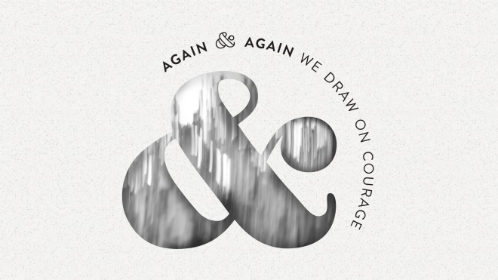PALM/PASSION SUNDAY
AGAIN & AGAIN, WE DRAW ON COURAGE
John 12:1-19
On Palm Sunday, we remember that Jesus’ entry into Jerusalem was not a risk-free, palm party. It was a protest parade—a protest against those in power, a
parade to prepare the way for a different kind of king. And this was all happening with plots to kill Lazarus (and Jesus) building in the background. We’re reminded that the crowds were brave to show up that day, and that Jesus drew on courage to face his journey to the cross. The root of courage is cour, meaning “heart.” Courage is deep within us; we often find it when we most need it, when everything else has been stripped away.
MAUNDY THURSDAY
AGAIN & AGAIN, WE ARE HELD TOGETHER

John 13:1-17, 31b-35
Footwashing is a practice of radical vulnerability, of being seen and known. Jesus loved the disciples “to the end.” In this act, we remember that God holds
all of our pain, vulnerability, doubts, and sufferings. As we venture toward the cross, we can lean into God’s everlasting arms, knowing we are held.
GOOD FRIDAY
AGAIN & AGAIN, WE FIND OURSELVES HERE

John 19:1-30
Again and again, we find ourselves at the foot of the cross, at the pit of despair, in the face of death, in the grip of state-sanctioned violence. “Here” is an emotional place. “Here” is grief. “Here” is the reality of sin and brokenness. On Good Friday, we are called to sit in the silence of death, knowing that God is here.
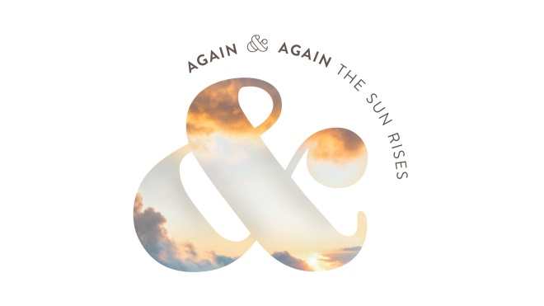
EASTER SUNDAY
AGAIN & AGAIN, THE SUN RISES
Mark 16:1-8
According to Mark, on the first day of the week, the women rise with the sun and buy spices to anoint Jesus’ body. They are shocked to find the tomb empty, and leave in fear and terror. Mark’s resurrection story is less triumphant than the other Gospel testimonies (as scholars believe the
remainder of Mark’s gospel was a later addition). In Mark’s version, we are reminded that Easter comes to us, again and again, even if we don’t know
what to make of God’s resurrection ways. Again and again, the sun rises. And some days, that is enough.
Lent 2021
Fairport UMC

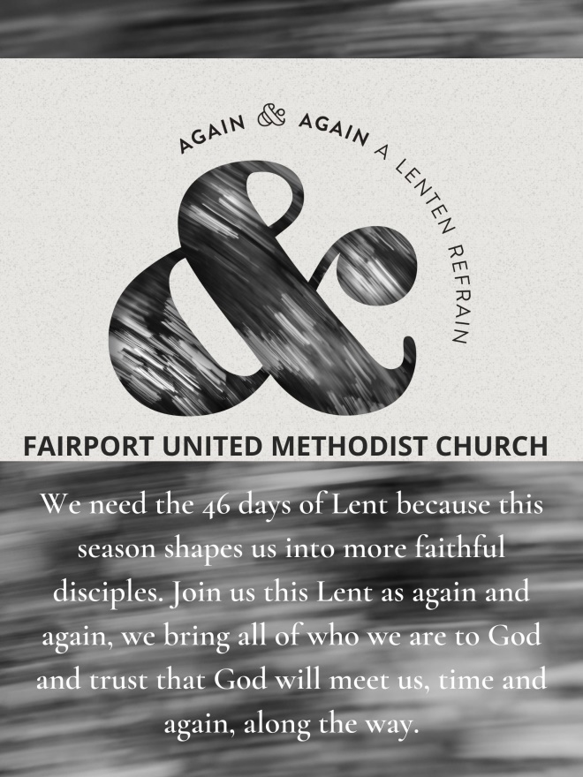
Series by A Sanctified Art LLC | sanctifiedart.org

Here is your Lent at Home bag from Fairport United Methodist Church. We wanted to ensure that you had a meaningful Lent this year as we worship from home.
Blessings, Pastor Richelle

Included in this bag:
- Devotional Booklet
- Jerusalem Cross (to hold as you pray your way through Lent)
- Ash Wednesday Service (burlap with charcoal)
- Prayer Cards (1 card per day)

