DOWNLOAD THE“FROM GENERATION TO GENERATION” ADVENT CALENDAR FOR FAMILIES HERE.

If you’d like to DOWNLOAD THE “FROM GENERATION TO GENERATION” Advent Devotional please contact the church office and we will email you a link!
The stories, scriptures, and traditions of the Christmas season have been passed down to us throughout the generations. Many of us enter this season with a swell of memories and emotions as vast as the cultural and religious rituals this holiday holds. Like a tapestry woven throughout time, the Christmas story weaves us in—to remember how God has shown up in the past, to continue the work of collective liberation, to behold the presence of God in flesh and bone.
Mary’s song of protest & praise from Luke 1.48b-50 echoes into today:
Surely, from now on all generations will call me blessed; for the Mighty One has done great things for me, and holy is his name. God’s mercy is for those who fear him from generation to generation.
Despite the challenges and vulnerability she faced, Mary could glimpse the scale and scope of the good news she was part of bringing forth. This good news transcends time and space—it was and is bigger than just her. Christ is coming for collective liberation: God’s redemption is at work for years to come. Therefore, the promise is meant to be lived out and passed on from generation to generation.
We encourage you to pay attention to each of the characters in these familiar narratives and ask:
- What did each person pass on or contribute?
- How did they either participate in God’s liberation and love—or try to thwart God’s justice?
- What can we learn from them, and what is our role now?
- What will we pass on to the next generation?
The root word of “generation” is “gen” meaning “origin” or “birth.” Our theme is also a call to action: what are we being called to generate or bring forth? What have your ancestors and those who have come before you passed on for you to continue? Who are the spiritual elders in your community who planted the seeds for the things that are now blooming? What seeds are you planting for the future?
From Generation to Generation… reminds us of the ways our lives, histories, actions, and stories are interconnected and woven together. The work of God is always unfolding—in and through us. This Advent, may you remember that you belong—to a story etched into the wrinkles of time, to generations that have come before and will come after, to a love that won’t let you go.

FIRST SUNDAY OF ADVENT (NOV 27):

THERE’S ROOM FOR EVERY STORY
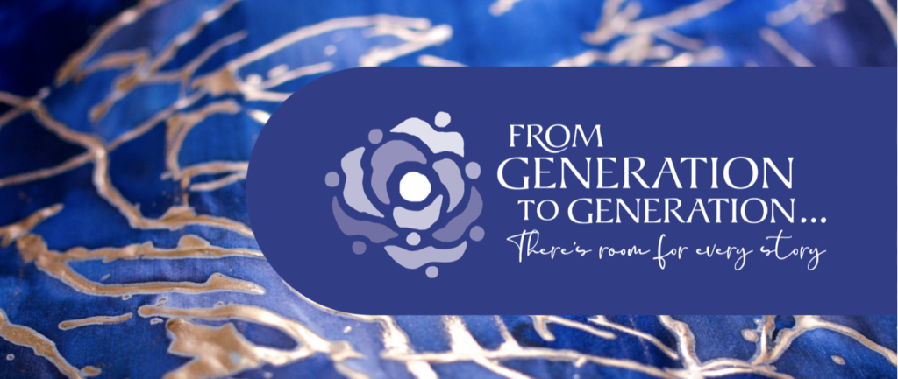Matthew 1:1-17 | Isaiah 2:1-5: Our worship series begins with Matthew’s genealogy. In that long list of names, we remember the trauma and triumph of those who came before; each name holds a story and their story gives way to Christ’s story. God works through the unexpected people and stories of the past and present. When you zoom in, you may not be able to see how each character propels the story forward, but when you zoom out, you can see how each story is woven together into a larger tapestry. The Isaiah passage illustrates a convergence of opposing groups and identities coming together. Instead of the way of the past—of war—they learn a new way by transforming their weapons into gardening tools. What are the old paths that we’ve followed, and where must we diverge into a new way?

SECOND SUNDAY OF ADVENT (DEC 4):

GOD MEETS US IN OUR FEAR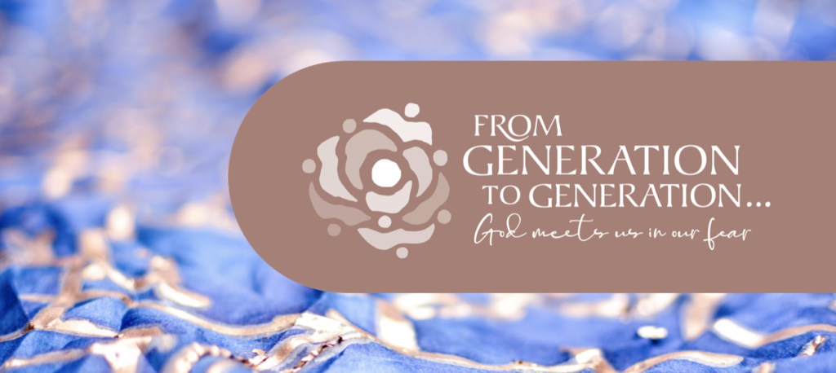Luke 1:26-38 | Isaiah 11:1-10: When the angel Gabriel comes to Mary, she is perplexed and confused—and no doubt, afraid. And yet, the angel’s news is: “Do not be afraid.” Do not be afraid. We hear this refrain all throughout the Christmas story and remember it is the most common phrase in all the bible. From generation to generation, God shows up in the midst of our fear and uncertainty and confusion. From generation to generation, faithful people have said, “yes,” despite apprehension. From generation to generation, our ancestors in faith have accepted the invitation. The prophecy in Isaiah paints a vision of what we work toward when we say “yes”: righteousness and equity reign, the wolf lives with the lamb, no harm or hurt shall destroy the earth, a child shall lead the way. This is the vision passed down to us: we must pursue it and make it real.

THIRD SUNDAY OF ADVENT (DEC 11):

WE CAN CHOOSE A BETTER WAY
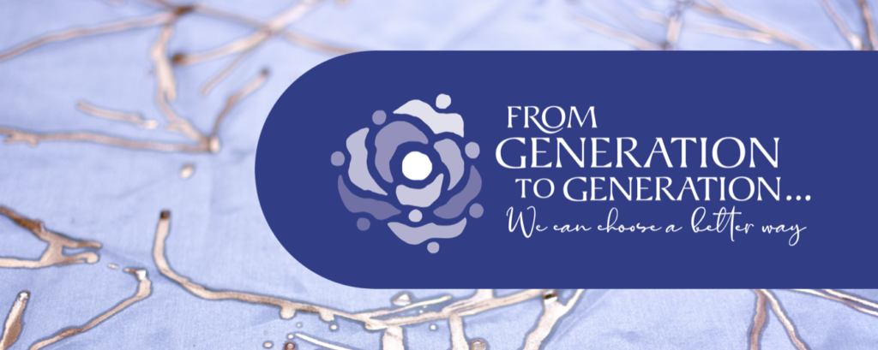
Matthew 1:18-25 | Isaiah 35:1-10: As far as Joseph knows, his new wife has been unfaithful to him and broken their marriage contract. And yet, instead of punishment, he chooses not to publicly disgrace or humiliate her. This interruption in his life becomes a holy invitation when the angel comes to him in a dream and says, “Do not be afraid.” When he awakes, Joseph once again has the courage to choose a better way. He chooses to stay with Mary, to become an adoptive parent. He chooses peace over violence, grace over condemnation. Like Mary, he chooses to say “yes.” When have our ancestors also chosen a better way, and when have they not? Isaiah 35 is a vision of what happens when we choose a better way: the wilderness blooms, water breaks forth in the desert, eyes are opened, ears are unstopped, sorrow and sadness flee away. A highway shall appear and it will become a holy way.

FOURTH SUNDAY OF ADVENT (DEC 18):

WE SEE GOD IN EACH OTHER
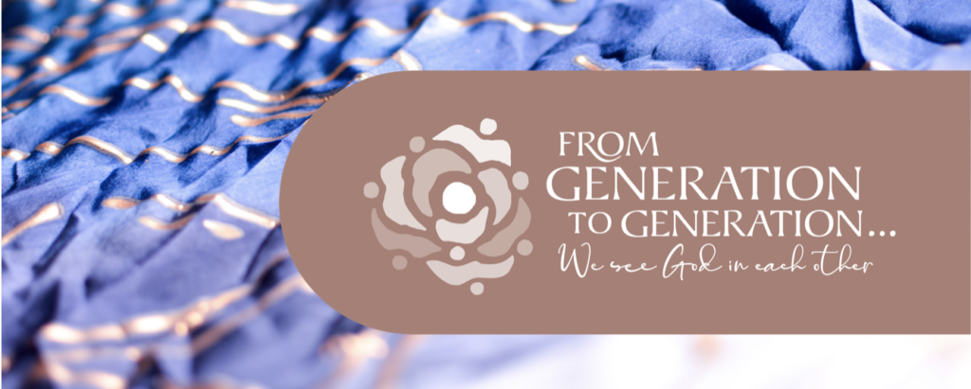
Luke 1:39-45; 56-58 | Luke 1:46-55: This week we return to Mary’s experience. After receiving the news from the angel, she retreats to her cousin Elizabeth’s house. When Mary arrives (perhaps unannounced), Elizabeth doesn’t just welcome her—she is filled with the Holy Spirit and speaks a blessing upon Mary as her own child leaps and kicks within her womb. She sees how God is at work and names it out loud. In this moment of profound solidarity, Mary and Elizabeth see the divine in one another. This connection inspires Mary to sing her radical hymn of praise, declaring how God’s liberating love remains steadfast throughout the ages. From generation to generation, we can see how God is at work in our relationships. We find God in each other. The way we see the divine in each other impacts how we live and move in the world. When we view every human being as a child of God, we generate a different world.

4PM, 8PM & 10PM CHRISTMAS EVE (DEC 24):

WE TELL THIS STORY
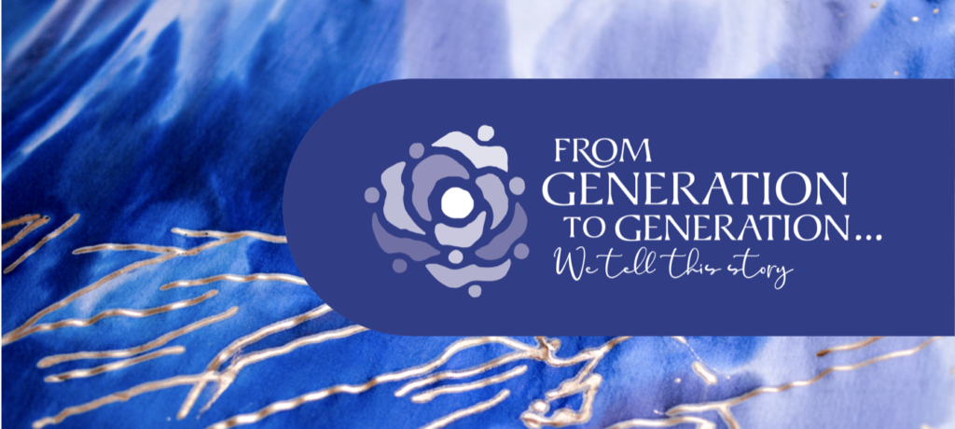
Luke 2:1-20: We tell this story every year. We tell this story because it illustrates so clearly God’s desire to be in relationship with us. We tell this story because we, too, are invited to come to the manger and witness the miracle of birth. We tell this story because it brings us hope and good news—hope especially for those deemed powerless, unworthy, or unwelcome. We tell this story because it is a story we need to hear again and again; if we didn’t tell it, what would become of our faith? And so, on this night, we tell this story to pass along this good news and to continue to thread together the generations with hope.

CHRISTMAS DAY (DEC 25):

GOD DWELLS WITH US
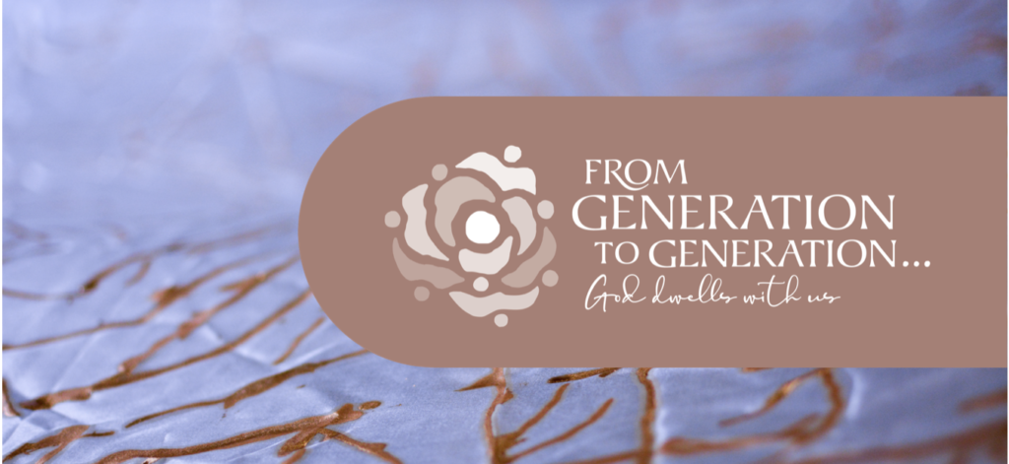J
John 1:1-14 | Luke 2:15-21 “And the Word became flesh and lived among us…” (John 1:14a). Unlike the other gospels, John’s gospel offers us a cosmic glimpse of Christ’s birth. Christ’s beginning was with God, therefore, Christ has been with us since life began. On this Christmas Sunday, we celebrate the many ways God dwells with us from generation to generation, since the beginning of time. Like Mary pondering the angels’ message in her heart, we invite you to dwell in your worship, perhaps embracing stillness, contemplative practices, creativity, and prayer. In the fullness of this season, come dwell with God—in silence or in song, in prayer or in stillness.

EPIPHANY (JAN 1):

WE KEEP SEEKING
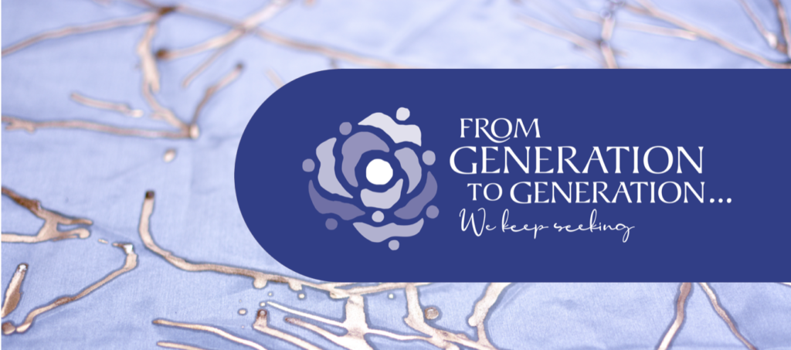
Matthew 2:1-12 | Matthew 2:13-23: The Magi were seekers. They sought wisdom, they sought the divine, they sought fortunes to tell the future. Their seeking leads them to Jesus, the newborn king of another culture and religion. And yet, their seeking is also what protects them from Herod’s deception and harm. After the Magi go home by another way, Joseph is visited again by an angel in his dream. This time, the angel brings a warning, and like before, Joseph heeds the message. Fleeing from Herod’s massacre, Joseph, Mary, and baby Jesus seek refuge in Egypt; they remain there, living as immigrants, until Herod dies. Like the Magi, may we seek the divine and be willing to journey closer to God. Like the Holy Family, may we seek safety for all families who are under threat. This new year and every year to come, let us keep seeking—wisdom, justice, and a better world.

Click to listen to the Advent and Christmas playlist from A Sanctified Art on Spotify!
